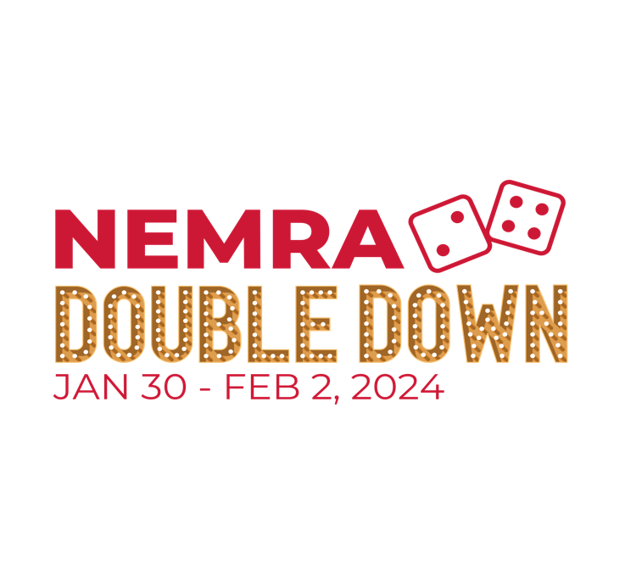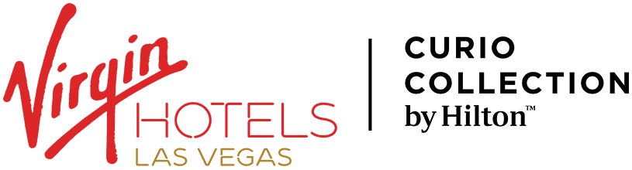

**OTHER HOTELS NEARBY THE VIRGIN HOTELS LAS VEGAS**

In the event you need to book a reservation at another hotel due to NEMRA’s block reaching full capacity at the Virgin Hotel, or for personal reasons, please see a list of hotels nearby Virgin. Please contact [nemra@nemra.org](mailto:nemra@nemra.org) if you have any questions!

1. **Hyatt Place Las Vegas**

**4520 Paradise Road, Las Vegas** (.3 miles to Virgin)

**P: (855) 270-4339**

1. **Club Wyndham Grand Resort**

**265 East Harmon Avenue, Las Vegas (.5 miles to Virgin)**

**P: (855) 279-0668**

1. **Marriott Grand Chateau**

**75 East Harmon Avenue, Las Vegas** (1.0 mile to Virgin)

**P: (855) 338-9955**

1. **MGM Grand**

**799 Las Vegas Boulevard South, Las Vegas** (1.6 miles to Virgin)

**P: (855) 261-9021**

1. **Planet Hollywood Resort & Casino**

**3667 Las Vegas Boulevard South, Las Vegas** (1.8 miles to Virgin)

**P: (855) 208-4301**

1. **Flamingo Las Vegas Hotel & Casino**

**3555 Las Vegas Boulevard, Las Vegas** (1.9 miles to Virgin)

**P: (855) 329-0862**