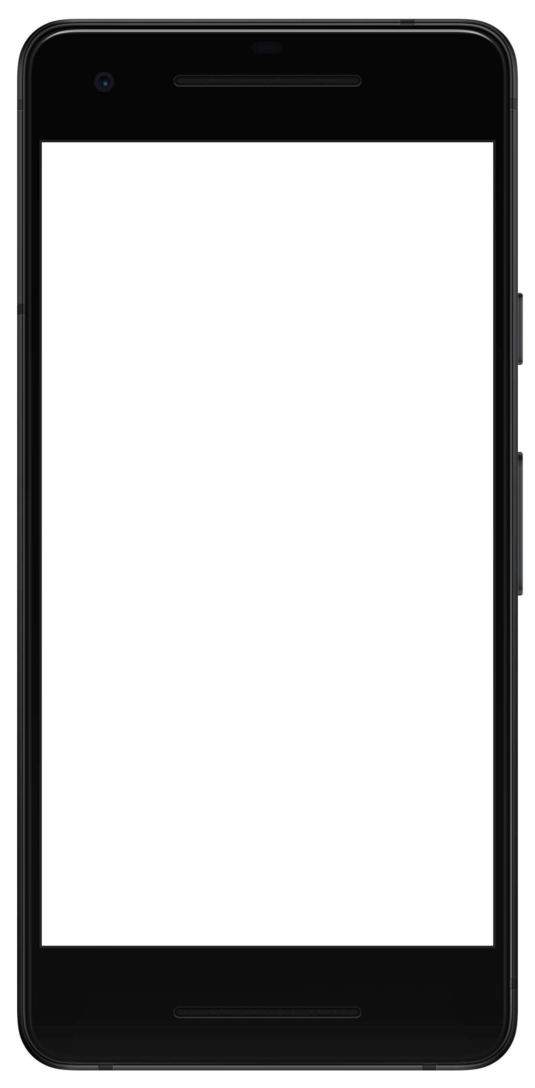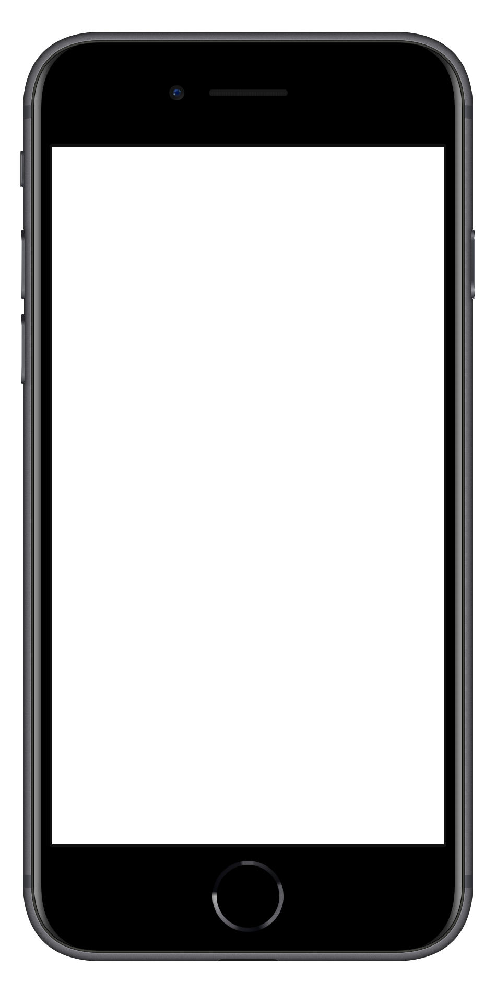

**Note:** Not all Android phones are the same. The directions below walk you through the most common OS, Android 9.0.

**1 Access the Notifications menu.** Open your device’s Settings app. Tap **Apps & notifications**.

**2 Turn on Notifications for the app.** Scroll down and tap **See all apps**. Find your event’s app on the list and tap its name. Tap **Notifications**, then switch **Show notifications** on.

**Or Android**

**1 Access the Notifications menu.** From the home screen, tap **Settings**, then **Notifications**.

**2 Turn on Notifications for the app.** Find your event’s app on the list and tap its name. Switch **Allow Notifications** on.

**On iOS**

**Allowing Push Notifications**